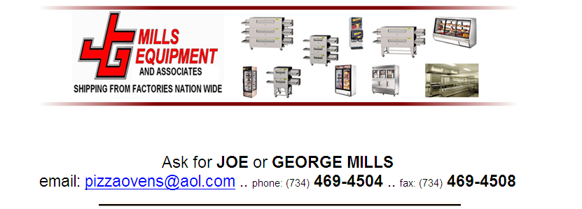
Jimex Corp.- ASCEND Mfg.
REFRIGERATED UNITS
2 YEAR PARTS AND LABOR WARRANTY
5 YEAR COMPRESSOR WARRANTY
PIZZA PREP TABLES (MAKE LINE)

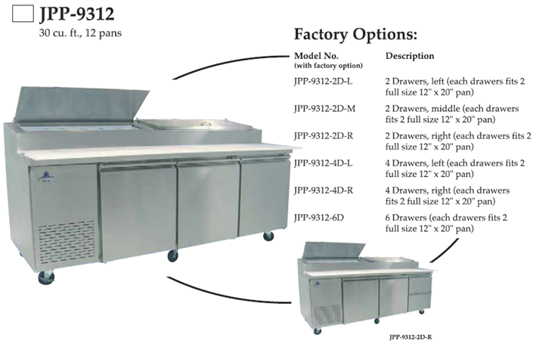

HOLDS 12 –1/3 PANS 92.8” LONG X 31.5 DEEP X 44.2” TO TOP ½ HP 115 V0LT

5 YEAR COMPRESSOR WARRANTY
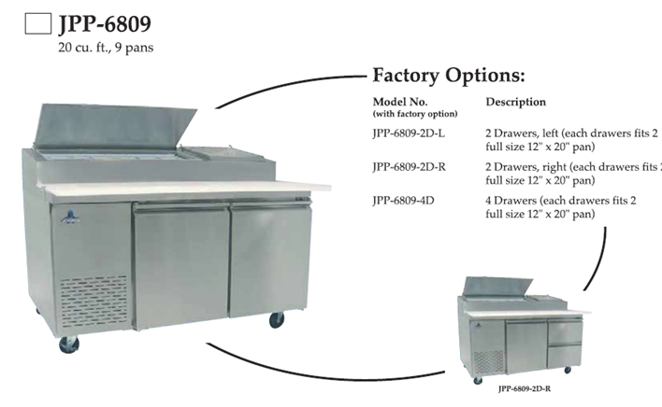
HOLDS 9 –1/3 PANS 67.8” LONG X 31.5 DEEP X 44.2” TO TOP 1/3 HP 115 V0LT
5 YEAR COMPRESSOR WARRANTY

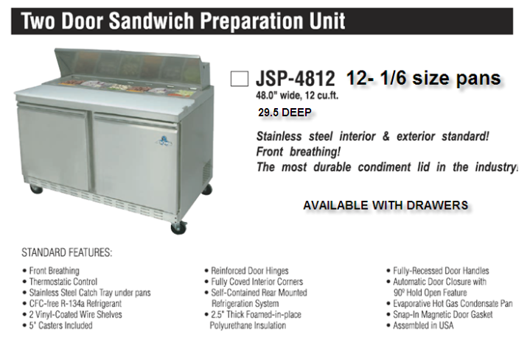
2 YEAR PARTS AND LABOR WARRANTY

5 YEAR COMPRESSOR WARRANTY
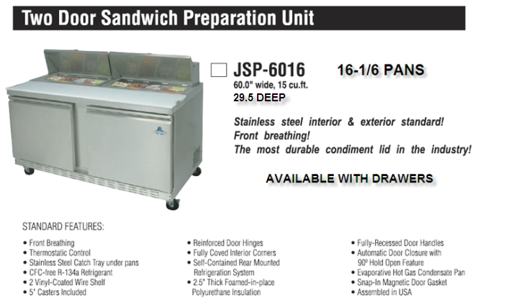

2 YEAR PARTS AND LABOR WARRANTY
5 YEAR COMPRESSOR WARRANTY

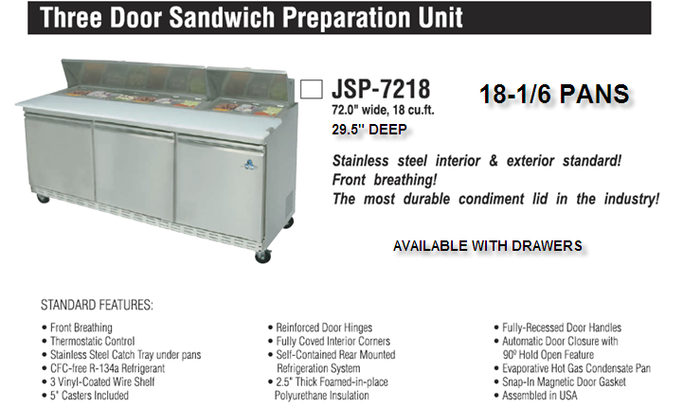
2 YEAR PARTS AND LABOR WARRANTY
5 YEAR COMPRESSOR WARRANTY
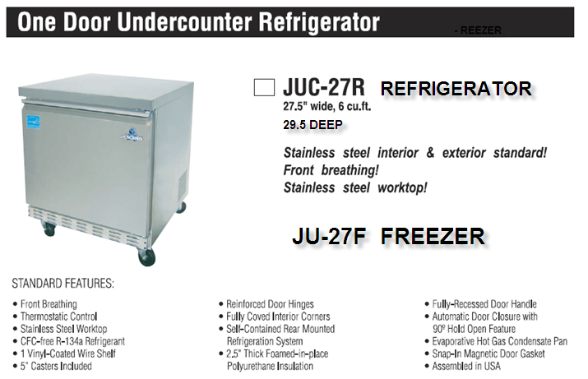
2 YEAR PARTS AND LABOR WARRANTY
5 YEAR COMPRESSOR WARRANTY
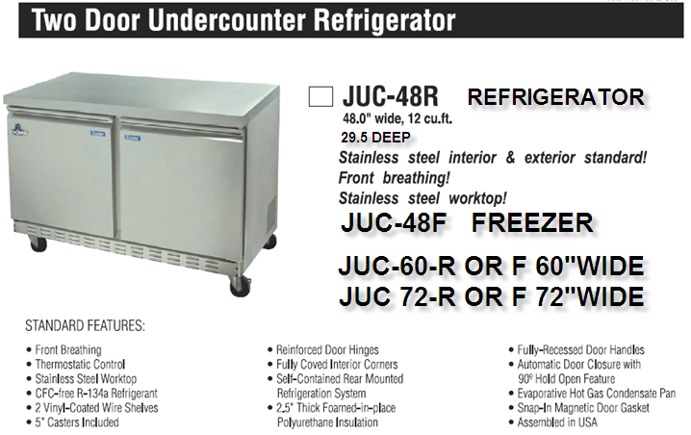
2 YEAR PARTS AND LABOR WARRANTY
5 YEAR COMPRESSOR WARRANTY
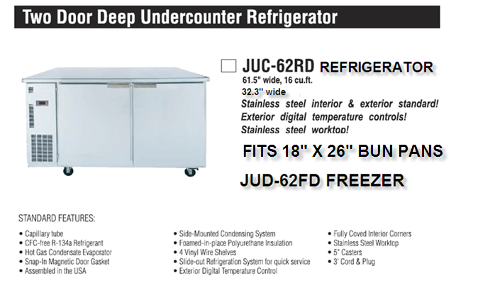

2 YEAR PARTS AND LABOR WARRANTY

5 YEAR COMPRESSOR WARRANTY

_______________________________________________________________________
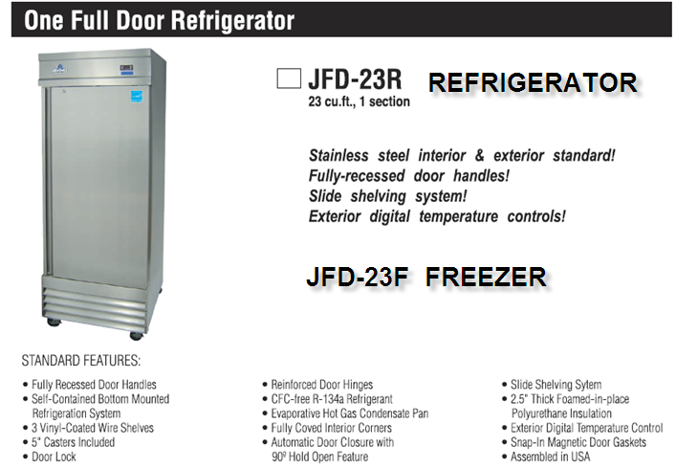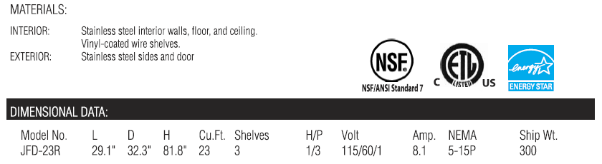

2 YEAR PARTS AND LABOR WARRANTY
5 YEAR COMPRESSOR WARRANTY

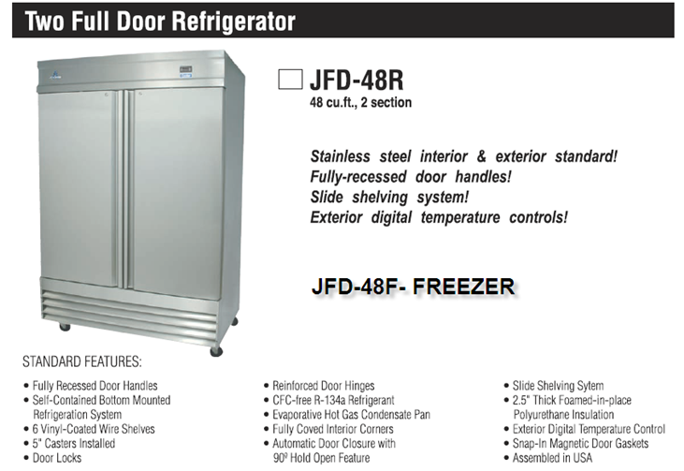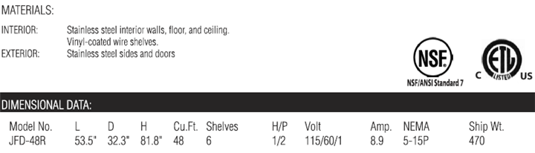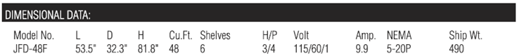

2 YEAR PARTS AND LABOR WARRANTY
5 YEAR COMPRESSOR WARRANTY
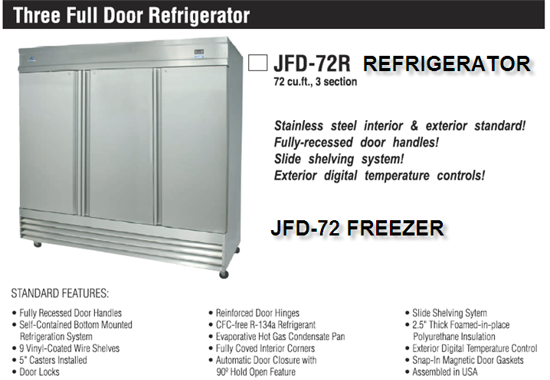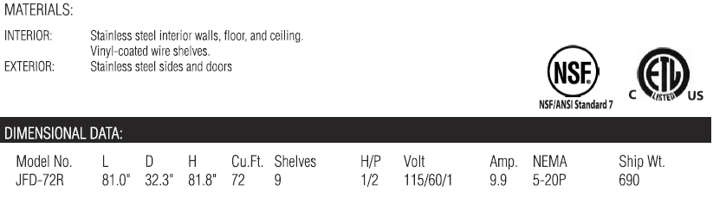
MODEL JFD-72 FREEZER
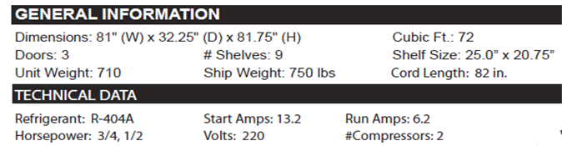

2 YEAR PARTS AND LABOR WARRANTY
5 YEAR COMPRESSOR WARRANTY

GLASS DOOR MERCHANDISERS

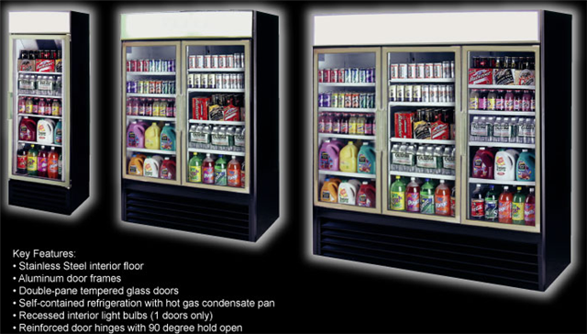
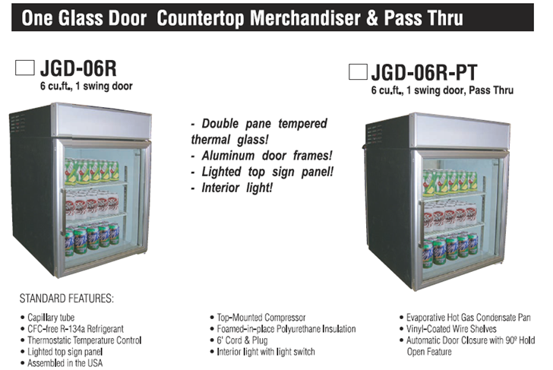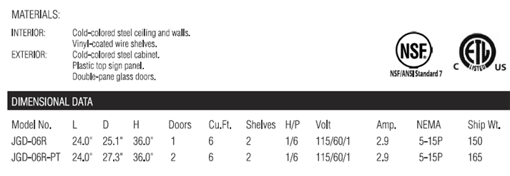

2 YEAR PARTS AND LABOR WARRANTY
5 YEAR COMPRESSOR WARRANTY


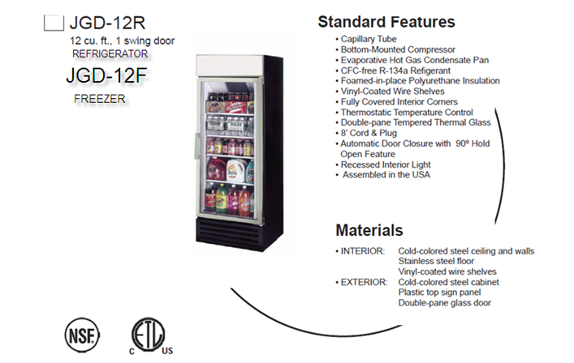
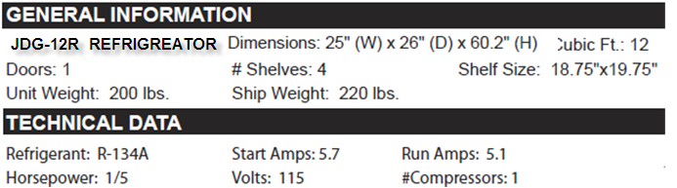
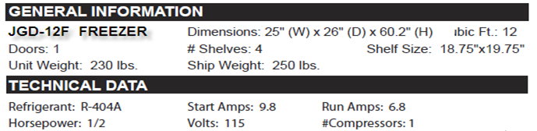

2 YEAR PARTS AND LABOR WARRANTY
5 YEAR COMPRESSOR WARRANTY

SINGLE DOOR 16 AND 23 CUBIC FOOT REFRIGERATORS
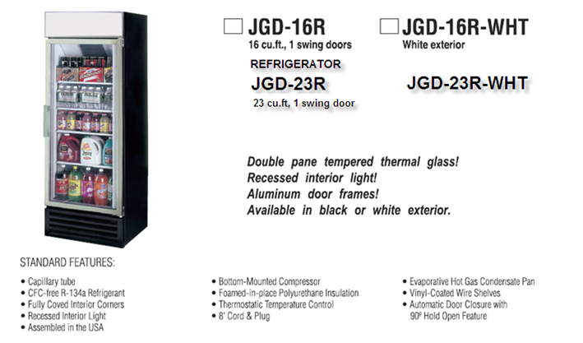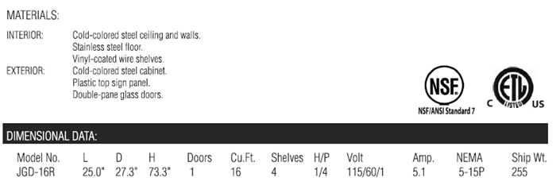
2 YEAR PARTS AND LABOR WARRANTY
5 YEAR COMPRESSOR WARRANTY

2 GLASS DOOR 48 CU FT REFRIGERATORS & FREEZER

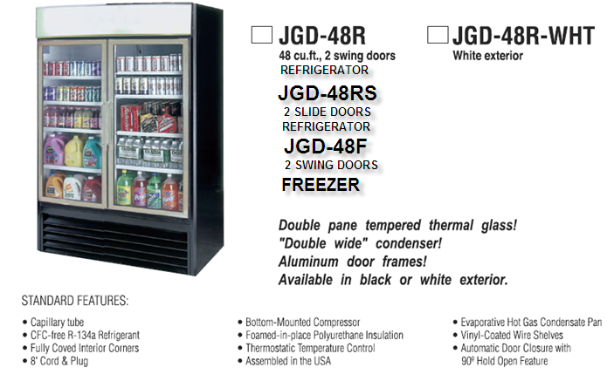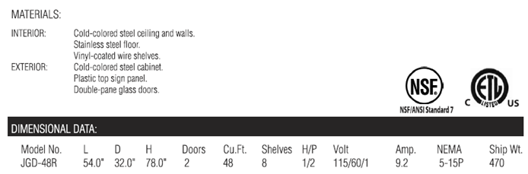
JGD –48RS SPECS ARE SAME AS ABOVE

JGD-48F 54.0” 32.0” 78.0” 2 48 8 3/4XL 220/115/60/1 5.7/4.0 6-15/5-15P 510

2 YEAR PARTS AND LABOR WARRANTY
5 YEAR COMPRESSOR WARRANTY

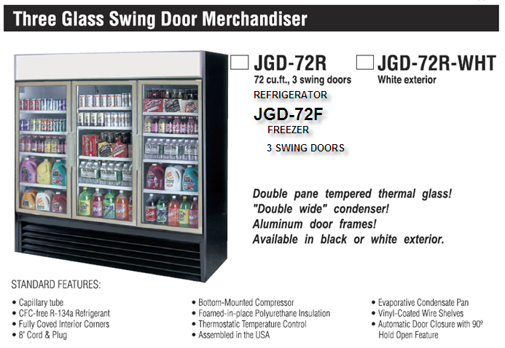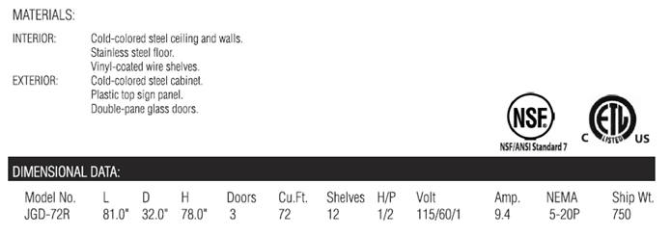
JGD-72F 81.0” 32.0” 78.0” 3 72 12 1XL 220/115/60/1 9.1/3.4 6-15P/5-15P 780

2 YEAR PARTS AND LABOR WARRANTY
5 YEAR COMPRESSOR WARRANTY

